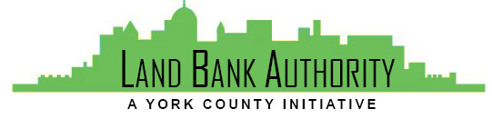
York County
Land Bank Authority

York County Land Bank Authority Board Meeting

Thursday, April 16, 2020 ● 4:00pm

Virtual Zoom/Phone Meeting

- Call to Order Tom Englerth

- Comments or Questions from the Public

- Approval of Meeting Minutes - February 2020 Tom Englerth

- Financial Statements December 2019 & February 2020 Tom Englerth

- YCLBA 2019 Audit Nancy Barry

- Project Discussion Kim Hogeman

  - Knowledge Park – Action
  - Habitat, Chestnut Street
  - 229 Carlisle Street
  - 254-256 Queen Street
  - 282 Cottage Hill
  - Logos Academy
  - 34 Frederick Street

- Good of the Order

- Next Meeting – May 21, 2020 3:30pm

- Adjournment

