York County
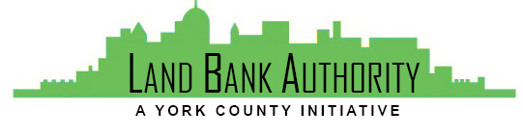
Land Bank Authority

Thursday, March 21, 2019
York County Economic Alliance
144 Roosevelt Ave, York, Pennsylvania

Members: Tom Englerth, Michael Black, Phil Briddell, Heidi Hormel, Frank Countess, Shanna Terroso, Felicia Dell
- Call to Order Tom Englerth
- Comments or Questions from the Public
- Approval of Meeting Minutes Tom Englerth
- YCLBA Operational Documents
  - County MOU - Pending Approval
  - Annual Reporting to DCED – Pending Audit
- Project Discussion Kim Hogeman
  - Project Presentation
    - York City – Feed Mill Preliminary Plans Nicole Davis
    - 254-256 S Queen Street Nicole Davis
- Good of the Order
- Next Meeting – April 18, 2019
- Adjournment

