York County
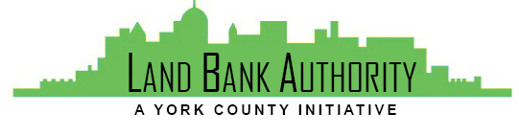
Land Bank Authority

Thursday, May 16, 2019
York County Economic Alliance
144 Roosevelt Ave, York, Pennsylvania

Members: Tom Englerth, Michael Black, Phil Briddell, Heidi Hormel, Frank Countess, Shanna Terroso, Felicia Dell
- Call to Order Tom Englerth
- Comments or Questions from the Public
- Approval of Meeting Minutes Tom Englerth
- YCLBA Operational Documents
  - County MOU - Pending Approval
  - Annual Reporting to DCED – Pending Audit
- Project Discussion Kim Hogeman
  - 229 Carlisle Street, Hanover Borough
  - 249-253 Roosevelt, York City Blanda Nace
- Action Items
  - 13 Church Ave, Felton Borough
  - 74 W Main Street, Windsor Borough
- Good of the Order
- Next Meeting – June 20, 2019
- Adjournment

