York County
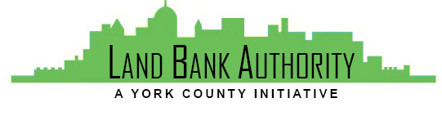
Land Bank Authority

Thursday, August 15, 2019
York County Economic Alliance
144 Roosevelt Ave, York, Pennsylvania

Members: Tom Englerth, Michael Black, Phil Briddell, Heidi Hormel, Frank Countess, Shanna Terroso, Felicia Dell
- Call to Order Tom Englerth
- Comments or Questions from the Public
- Approval of Meeting Minutes Tom Englerth
- 2018 Audit Draft – Action Nancy Barry
- Financial Statements – May-June 2019
- YCLBA Operational Documents
  - Annual Reporting to DCED – Pending Audit
- Proposed Project Discussion Kim Hogeman
  - Zion Elementary, Fairview Township
  - 22 York Street, Jefferson Borough
- Pending Projects
  - 229 Carlisle Street, Hanover Borough
- Current Project Updates
  - 13 Church Ave, Felton Borough
  - 74 W Main Street, Windsor Borough
- Good of the Order
  - Commissioners Meeting – October 30th in Hanover
- Next Meeting – September 19, 2019
- Adjournment

