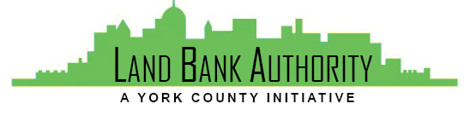
York County
Land Bank Authority

York County Land Bank Authority Board Meeting

Thursday, April 15, 2021 ● 3:30 PM

Virtual Zoom/Phone Meeting

- Call to Order Tom Englerth

- Comments or Questions from the Public

- Approval of Meeting Minutes – March 25, 2021 Tom Englerth

- Approval of Financial Statements – March 2021 Tom Englerth

- 2021 Judicial Sale

  - RDA
  - Four Squares Development
  - Elite Properties

- New Projects Kim Hogeman

  - Glen Rock Borough – analysis review

- Project Update Kim Hogeman

  - Project Scoring – ongoing

- DCED Grant Amended Resolution – Action Kim Hogeman

- Good of the Order Tom Englerth

- Next Meeting – May 20, 2021

- Adjournment

