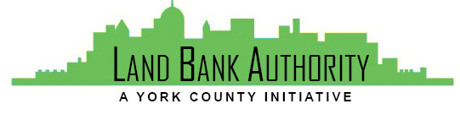
York County
Land Bank Authority

York County Land Bank Authority Board Meeting

Thursday, July 15, 2021 ● 3:30 PM

Virtual Zoom/Phone Meeting

- Call to Order Tom Englerth

- Comments or Questions from the Public

- Approval of Meeting Minutes – June 17, 2021 Tom Englerth

- Approval of Financial Statements – June 2021 Tom Englerth

- Project Update Kim Hogeman

  - Spring Grove, 65 S Main – Action
  - 319-335 N George Street – Action
  - RSDC, Philly Café - Action
  - Thackston Homes - Update
  - Red Lion Borough – Update

- Good of the Order Tom Englerth
  - Dover Twp/Habitat Shovel Ceremony

- Next Meeting – August 19, 2021

- Adjournment

