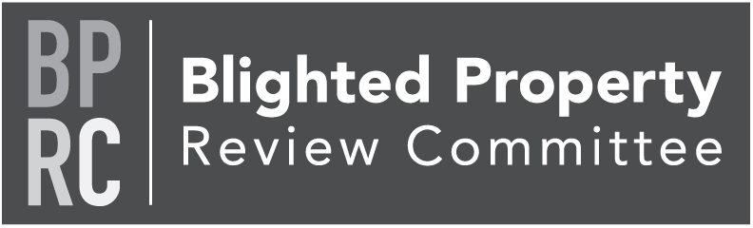

Thursday, October 14, 2021
YCEA Office, Upstairs Board Room
https://us02web.zoom.us/j/366212397
Zoom Meeting via phone: 301-715-8592
Meeting ID: 366 212 397

Members: Tom Englerth, Joianne Galiano, Eric Mains, Connie Stokes, Diane Price, John McLucas, Mark Derr, Cindy Seibel

- Call to Order Tom Englerth
- Executive Session Solicitor Doyle
- Comments or Questions from the Public
- Approval of Minutes – July 8, 2021 – Action
- BPRC Project Updates & Discussion Kim Hogeman
  - 1 East Franklin, New Freedom Borough – Update
  - Blight Determination Resolution - Action
- Good of the Order
- Next Meeting – January 13, 2022
  - Reminder 2022 meeting dates: April 14, July 14, & October 13
- Adjournment

