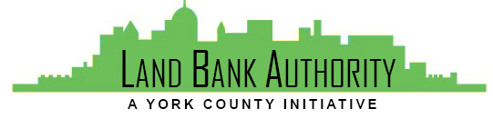
York County
Land Bank Authority

York County Land Bank Authority Board Meeting

Thursday, October 21, 2021 ● 3:30 PM

Hybrid Zoom/In-person Meeting
144 Roosevelt Avenue York, PA 17401
Join Zoom Meeting
https://us02web.zoom.us/j/538759070

- Call to Order Tom Englerth

- Comments or Questions from the Public

- Approval of Meeting Minutes – September 16, 2021 Tom Englerth

- Approval of Financial Statements – August and September 2021 Tom Englerth

- Project Update Kim Hogeman

  - Four Square Development – Analysis Review / Action
  - Gay & Todd Kaltreider Property – Update / Action
  - Eastern Blvd Development – Update
  - Dallastown Borough Property – Presentation / Action
  - Logos Academy - Action

- Good of the Order Tom Englerth
  - Strategic Planning Retreat Wednesday, October 27th 10:00 – 1:00

- Next Meeting – November 18, 2021

- Adjournment

