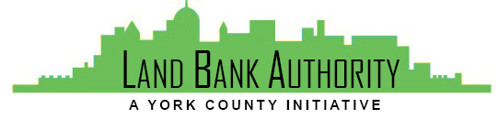
York County
Land Bank Authority

York County Land Bank Authority Board Meeting

Thursday, December 16, 2021 ● 3:30 PM

Hybrid Zoom/In-person Meeting
144 Roosevelt Avenue York, PA 17401
Join Zoom Meeting
https://us02web.zoom.us/j/538759070

- Call to Order Tom Englerth

- Comments or Questions from the Public

- Approval of Meeting Minutes – November 18, 2021 Tom Englerth

- Approval of Financial Statements – November 2021 Tom Englerth

- Project Update Kim Hogeman

  - Foundry Property – Presentation / Action
  - Horn Farm Project – Presentation
  - Salem Ave – Reimbursement Request
  - Glen Rock – Reimbursement Request

- Strategic Plan – Action Tom Englerth

- Next Meeting – January 20, 2022 (Annual Meeting)

- Adjournment

