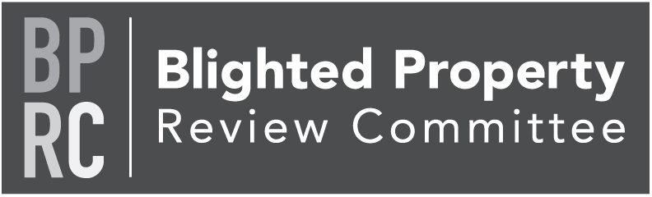

Thursday, April 14, 2022
https://us02web.zoom.us/j/366212397
Zoom Meeting via phone: 301-715-8592
Meeting ID: 366 212 397

Members: Tom Englerth, Joianne Galiano, Eric Mains, Connie Stokes, Diane Price, John McLucas, Cindy Seibel

- Call to Order Tom Englerth
- Comments or Questions from the Public Tom Englerth
- Approval of Minutes – January 13, 2022 – Action Tom Englerth
- County LERTA Program Discussion Kim Hogeman
- Good of the Order
- Next Meeting – July 14, 2022
- Adjournment

