York County
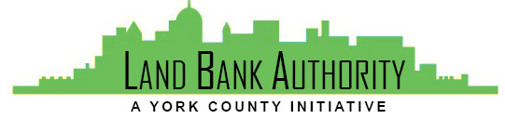
Land Bank Authority

Thursday, August 17, 2023
Hybrid Zoom/In-person Meeting
144 Roosevelt Avenue York, PA 17401
Join Zoom Meeting
https://us02web.zoom.us/j/538759070

Members: Tom Englerth, Michael Black, Phil Briddell, Heidi Hormel, Frank Countess, Shanna Terroso, Felicia Dell, Tim Staub
- Call to Order Tom Englerth.
- Comments or Questions from the Public
- Meeting Minutes – July 20, 2023 Tom Englerth
- Financial Statements – July 2023 Tom Englerth
- Project Update Kim Hogeman
- New Project Presentation Kim Hogeman
  - Inch Sports Complex, North York Borough
- Strategic Plan Update Kim Hogeman
- Good of the Order
- Adjournment

