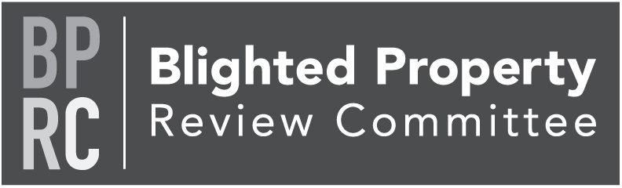

Thursday, October 12, 2023
https://us02web.zoom.us/j/366212397
Zoom Meeting via phone: 301-715-8592
Meeting ID: 366 212 397

Members: Tom Englerth, Joiann Galiano, David Garabedian, Eric Mains, Greg Monskie, John McLucas, Cindy Seibel

- Call to Order Tom Englerth
- Comments or Questions from the Public Tom Englerth
- Approval of September 2023 Minutes - Action Tom Englerth
- Project Update Bronley Martin
  - 333 N Pleasant, Dallastown - Action
- LERTA Program Update Bronley Martin
  - West York Borough Storage Space - Update
- Good of the Order
- Next Meeting – November 9, 2023
- Adjournment

